# Ottawa University

## Gwartney Institute for Freedom, Justice, and Human Flourishing

### Objectives

1. **Expand the philosophy, politics, and economics (PPE) program through high quality coursework and events to engage more students.**
   1. Do you feel the institute met this objective for the semester? Why or why or not?

Yes, the Gwartney Institute has met its goal for the PPE program this year. Our students continue to grow in knowledge of Philosophy, Politics, and Economics as shown by the success of the students inside and outside of the classroom. This is best exemplified by the success of PPE major Sharon Cousineau.

Sharon elected to compete in the undergraduate research program at the Association for Private Enterprise Education annual meeting. The competition included around thirty students from schools across the country as well as some international competitors. Out of all the presentations, Sharon won 1st Prize.

Her paper was titled ‘Corruption and Entrepreneurship’. The paper examined the relationship between corruption and entrepreneurial activity, and how this relationship affects economic growth. The sources she used show quantitative results about how corruption undermines entrepreneurship and therefore economic growth.

Sharon’s training for writing the paper was provided by Gwartney Institute classes and professors. Dr. Clarke has taught many classes for Sharon and has connected her to PPE content and experts in and out of the university. Dr. McCullough also taught her *Entrepreneurial Economics*, a key course for a paper like this.

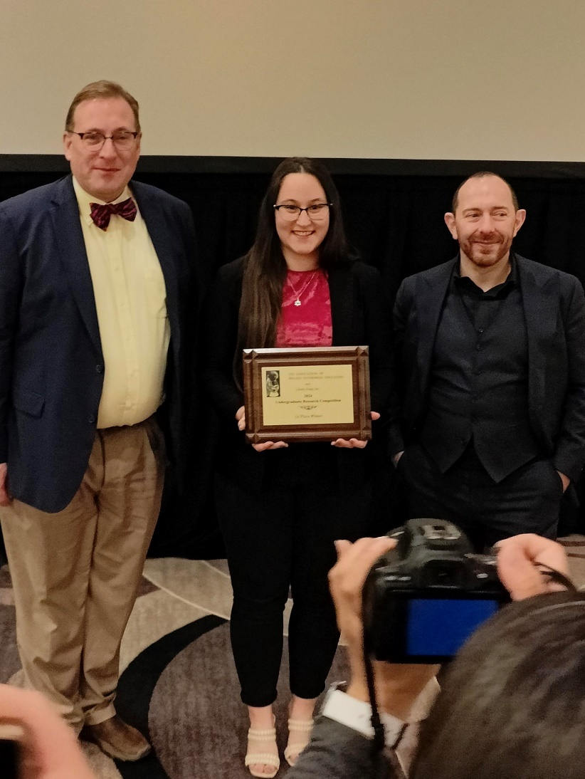

Sharon won several awards from the Gwartney Institute and the PPE major at Ottawa University’s end of year award ceremony, and she represents exactly the sort of student the Gwartney Institute seeks to build up. Sharon is one of the earliest PPE majors at Ottawa University, and we look forward to seeing her success replicated in future students for years to come.

The success of PPE students also carried into our PPE League team this year. This year, Ottawa University won first place in PPE League, edging out second place competitor (and last year’s champion) Lindenwood University. The students competed using their knowledge of money and banking—a topic covered by the Spring colloquium.

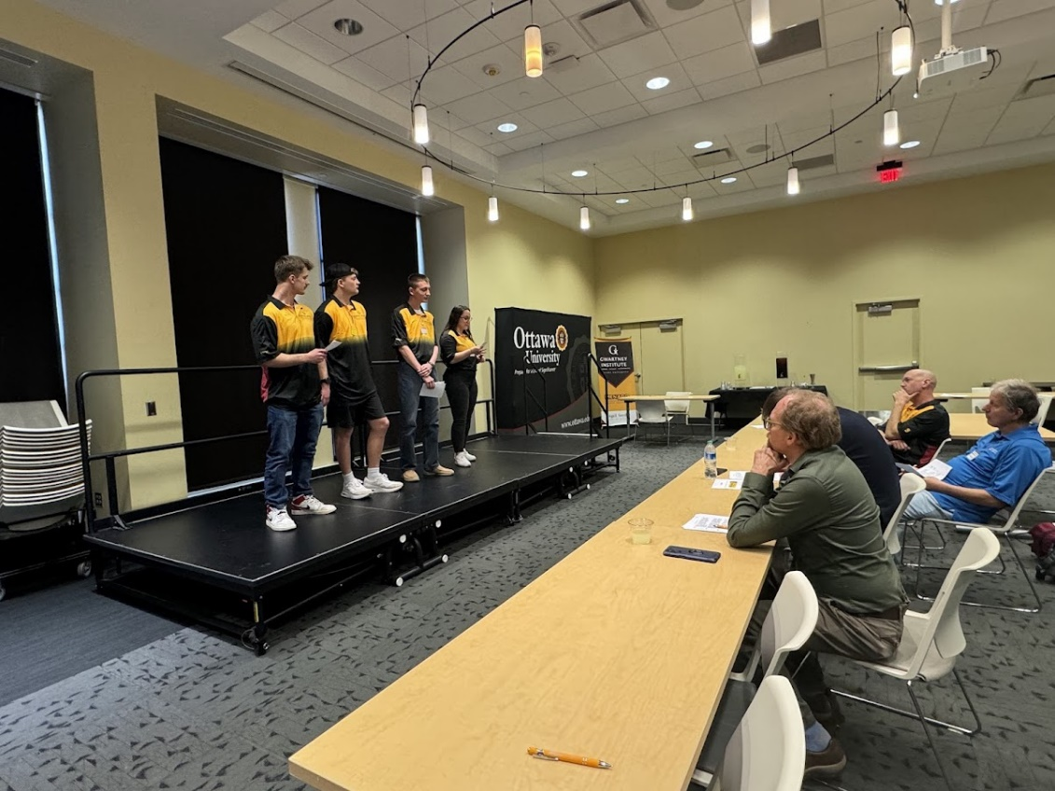

* 1. How many students are currently majoring in PPE as of the spring semester? What are some examples of the courses those students are taking?

In the spring semester, we continued to have seven PPE majors and several other students majoring in economics and philosophy who take PPE Courses. Here are some of the major courses for those students.

**PHL 33024 Ethics and Society**

This Spring Dr. Clarke taught the PPE major course Ethics in Society. One interesting feature of this class is it includes both majors and nonmajors trying to fulfill university requirements. As you’ll see reflected in student comments, Dr. Clarke was able to draw the interest of both types of students.

Here are some comments:

“Coming into this course, I wasn't sure how it would go. I've heard many stories about students who have taken a class similar to this, and if they disagreed with the instructors, they would receive a bad grade. that was not the case with this course, Mr. Clarke did an exceptional job of teaching to help us understand the material, and allow us to form our own opinions. He regularly would remind us that he didn't care what our stance on a topic was, he simply wanted to help us argue and communicate well. His feedback on reading responses was very helpful and the example he used in class helped me to understand the topic, theory, or concept being discussed.”

“I really wasn't a fan of this class coming in but professor Clarke made the course a little bit more interesting as he taught it.”

“The only reason I took this class was because of Professor Clarke. He is easily my favorite professor, helps understand the subjects in class, especially in a philosophy class in which the curriculum is hard to understand and get a grasp on.”

**ECON 49000 Economics Capstone**

Several of our Menard program participants are economics majors and completed their major with Dr. Peter Jacobsen in the economics capstone course. In this course, students write an economic research paper with original quantitative work. Two students, Zeke Reazin and Hannah Serquina, previously took the Political Economy course taught by Professor Jacobsen, and both have been frequent participants in Menard-sponsored colloquia and book clubs. Zeke Reazin, for example, wrote his final research paper on whether there was a connection between player performance and future pay in the NFL. Other students examined topics like crime, immigration, and economic growth.

* 1. How many events and activities has the institute conducted this semester? What was the total attendance of those events? Can you give a highlight of 2-3 of those events?

The institute hosted and facilitated student participation in seven events in the Spring semester. Here is a summary of each.

**Debate Night**

**Date: 2/2/2024**

**Attendance:** 42

Dr. McCullough and Dr. Reggies Wenyika debated the topic of “shareholder vs. stakeholder capitalism.” Dr. Jacobsen moderated. Each debater was given an opening statement and time for a rebuttal. Students in the audience were then offered the chance to ask questions.

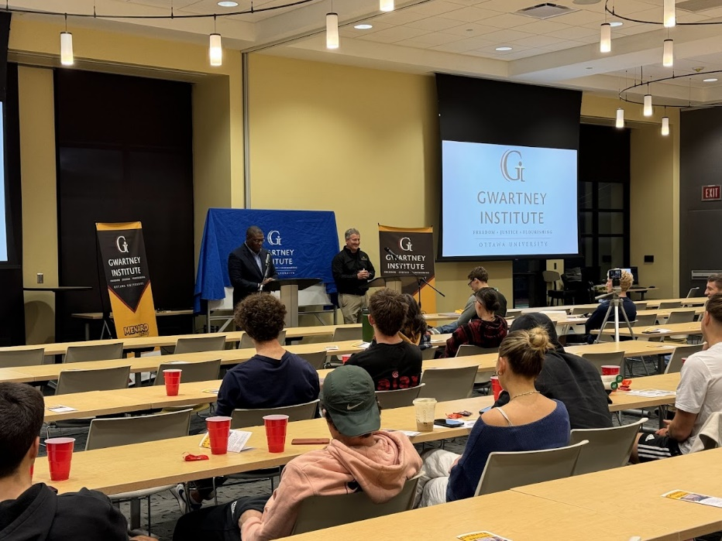

The full debate can be viewed on the Institute’s YouTube page: <https://www.youtube.com/watch?v=7QNFuewiI_0>

Students said:

“It really broadened my view on stakeholder vs. shareholder. I think your side depends mostly on perspective. I really learned a lot. I learned a lot about empathy.”

“Great debate tonight. Both parties had great points and expressed their opinions clearly and supported by facts. People, businesses and profit go hang by hand. My opinion is that we as consumers are also responsible, I know we are discussing business and their responsibilities but we as consumers are also responsible.”

Students also rated their knowledge before and after the event:

**Future of Money Colloquium**

**Date: 3/2/2024**

**Attendance: 13**

For our book club this semester, we did a colloquium titled, “The Future of

Money”. This colloquium took readings from various historians, philosophers, and economists on the history and nature of money. Here is a list of the readings:

Murray Rothbard “Mystery of Banking” Chapters 1, 3

Nick Szabo: Shelling Out “The origins of money”

Milton Friedman: “The Cure For Inflation”

Alan Greenspan: “Gold and Economic Freedom

Roger W. Garrison: “The “Costs” of a Gold Standard

F. A. Hayek: “Denationalization of Money”

F. A. Hayek: “Putting Private Money Into Circulation”

R. A. Radford: “The Economic Organization of P.O.W. Camp”

James D. Gwartney: “Yes, This Time We’ll Have Inflation and Here is Why”

David A. Harper: “Foundations of Entrepreneurship and Economic Development”

The students gave great comments about the colloquium:

“This was a very insightful conversation. I think we had great discussions on why inflation happens, how the government plays a role in the monetary system. We also had great conversations on why money developed and the different types in money we see in society today.”

“it was a very enriching experience. Coming from France, we never have this type of event or gathering so I am very happy to have participated.”

“Great discussion and great event from the Gwartney Institute! Thank you Russ and his team for letting me participate and expand my knowledge on money, the history of money and its usage. I enjoyed the fruitful discussion and really appreciate the diversity of opinions and students! Being a part of these events has always brought me great insight on the topic presented and it has helped me improve my critical thinking skills, as well as listening skills and of course my knowledge of business.”

Students also rated their knowledge before and after the event:

**PPE League**

**Date: 4/5/2024**

**Attendance: 28**

This year we had our fourth annual PPE League—an intercollegiate competition where students compete using knowledge of PPE. This year’s theme was “The Future of Money”. Like previous years, the competition consists of several components including a commercial competition, game theory, strategic video game competition, and the policy case competition. The competition included Lindenwood University, Pitt State University, newcomer Northwood University, and Ottawa University.

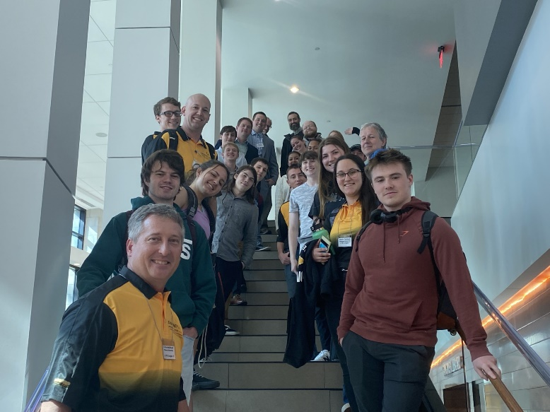

In the commercial competition, students make commercials related to the readings they received about money and banking. The commercials are available on the Gwartney Institute YouTube Page. Here is the link to an example of a commercial from Lindenwood University:

<https://www.youtube.com/watch?v=Er1Kxlio5qg>

Students gave comments about the commercial competition:

“I believe our video help people understand the Future of Money simply because we have narrative and it’s a simple knowledge that can be obtained by many.”

“The commercial event was fun. It was interesting to see the similarities between the commercials this year, versus last year. I think it would help others.”

“I loved the commercial competition. It’s a fun and creative way to incorporate the topic and learning.”

In the game theory competition, students make strategic decisions to earn points against opponents. This year we played a modified “prisoner’s dilemma” game. Each university had two teams. One team was allowed to engage in conversation, but the other had to remain silent.

Students gave comments about the game theory competition:

“This was my favorite part of the competition, it is fun getting to strategize the best way to earn the most money. In retrospect, it would have been more beneficial to agree to go back and forth with the other player in defecting and cooperating (when communication was allowed) because it would have earned us more points.”

“I LOVED IT. It truly stressed me out and I was not playing. I believe the results of each game should stay in silence, just to make it more interesting.”

“Requires careful strategy as well as persuasive skills. Enjoyed watching!”

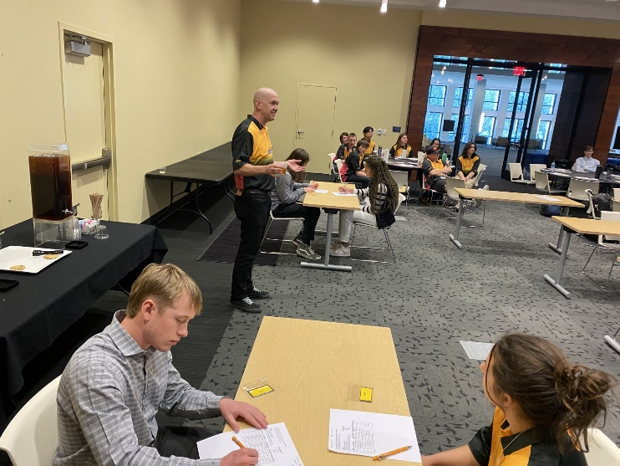

In the strategic video game competition, we’ve continued to use an online

game similar to Settlers of Catan. Students gather resources and trade to earn points.

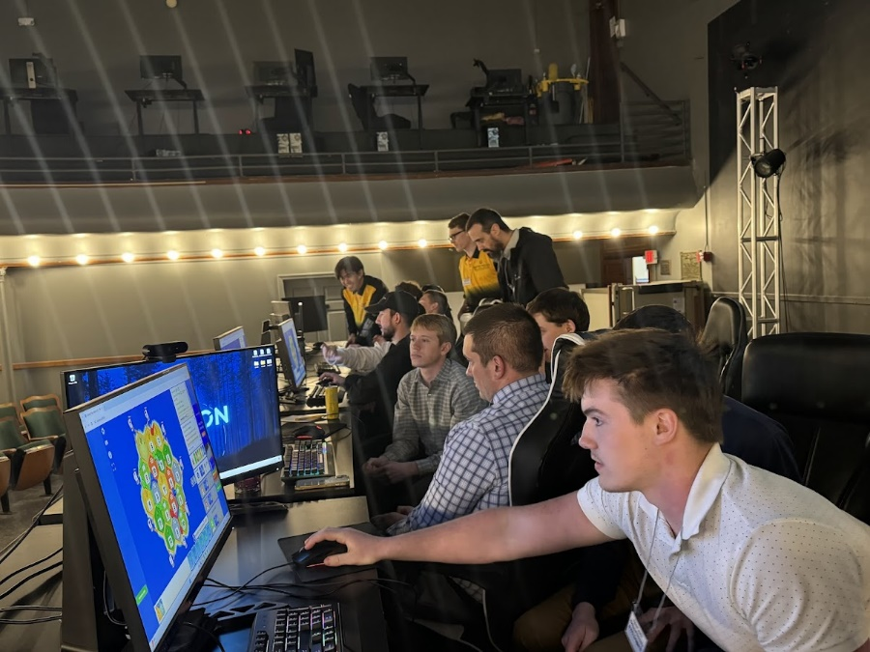

Students gave comments about the video game competition:

“The event went smoothly and quickly. I think that this particular game showed the advantages and drawbacks of the barter system extremely well.”

“It's a nice change of pace.”

In the policy case competition, students had 15 minutes to prepare to answer a spontaneous question about policy. We asked students whether they believed a central bank digital currency should be established.

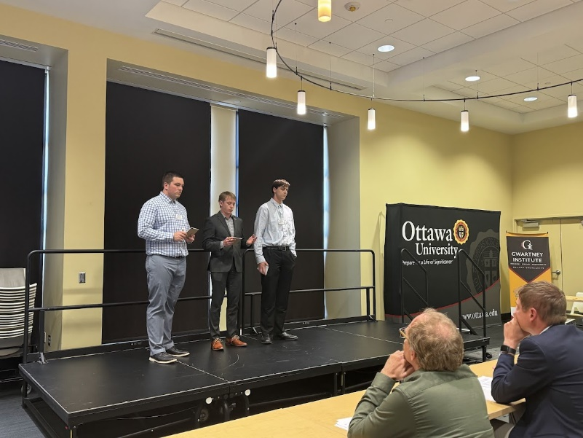

Students gave comments about the policy case presentation:

“I always enjoy the policy case. It’s the most exciting moment where the whole team comes together at crunch time.”

“I enjoy how these topics are always related to current issues and topics that are actively debated by economists in the real world.”

“I enjoyed this event the most out of any of the events. I liked being able to help come up with a case for the question. I also enjoy how everyone is a part of the process.”

**Debate Night Arizona/Online**

**Date: Asynchronous**

**Attendance: 45**

45 students from our campuses outside of our Kansas main campus signed up to watch a recording of a debate we hosted on the main campus. 13 students met all the criteria to be paid the honorarium.

Feedback from Mary: Explores topics not otherwise covered in the curriculum, depending on the chosen major. It would be great to see more of these events online.

Feedback from Kennedy: I think these types of events should continue online. It was very interesting to hear the two differing perspectives on this topic. I enjoy debates so any sort of debate will be likely to enrich my education.

Feedback from Joanne: I loved it! Yes, please keep doing these events as more and more people can have access to these insightful videos.

**Guatemala Student Trip and Presentations:**

Partnering with Ottawa University, the Institute supported partial travel scholarships for two students who helped Dr. McCullough facilitate two active learning activities with rural Guatemalan families that work with Education and More, a non-profit company. The Gwartney Institute coloring book was used by the children to color while Dr. McCullough reviewed short lessons on Economic Freedom that are contained in it. Attendees were given a few extra ones and they agreed to distribute them to other friends and family to help spread the message. The books are written in Spanish and English. The second activity was the trade game where the students helped record and facilitate the event.

Feedback from Abby: The people we met, surrounded us with unimaginable kindness and shared their culture with us. They invited us into their homes and provided food for us. We played with their children and brought them some color books.

Feedback from Cole: It was a great life lesson for me both to see the importance of serving others and to not take anything for granted. Thank you to all who made the Gwartney Institute 2024 Guatemala trip possible.

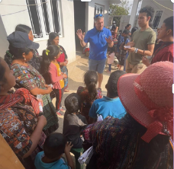

**Two Students attended a Ball State University Colloquium:**

**Attendance: 2**

**Dates: 2/9/2024-2/10/2024**

The Institute sponsored Sharon Cousineau and Elise Romine to participate in a discussion colloquium on the writings of Frederick Douglass in Indianapolis on February 9 and 10, 2024.  Discussions centered on Douglass’ ideas beyond abolition -- political violence, social change, women’s rights, rights of immigrants and workers, and others.

Feedback from Sharon: BSU Fishers colloquium on The Writings of Frederick Douglass was an overall wonderful experience. The colloquium fostered a deeper understanding of not only the historical relevance of Douglas, but the contemporary relevance of his beliefs as well.

Feedback from Elise: The Ball State colloquium was an enriching experience as having the opportunity to explore the history of civil war in the United States from the perspective of a former slave, such as Fredrick Douglass, is too often glossed over in many history curriculums. He had an interesting variety of opinions on politics, including specific political leaders, as well as economics that evolved throughout his lifetime. Many of which I would still be unaware of if not for this colloquium.

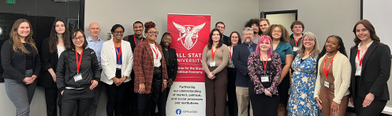

**Four Students attend Humanomics Conference:**

The Institute supported four students to attend the 2024 Humanomics Symposium at Creighton University which brings together students and faculty from 10 different universities for a weekend of reading, discussion, and thinking on “Innovation, Religion, and the State of the World.”

Feedback from Nadia: This even exceeded my expectations. It was well organized from the shuttles to the food itself it was all up to standard. The organization of the entire event was also phenomenal. The discussions themselves were productive with the faculty members who were present being a great guide without imposing on the discussions themselves.

Feedback from Sharon: This was a very insightful symposium. We talked a lot about if and how we should integrate new technology into institutions and why institutions don't keep up with technological change. We also discussed how liberal and religious values will be important in the coming years as advancement and change continue at an increasing rate. The Friday night speaker, Walter Russell Mead, was particularly interesting. He discussed a need for a return to teaching leadership and thinking skills in higher education to fight the trend of credential inflation.

Feedback from Angelique: Overall the experience was very eye opening and I had a great time. I was very excited to meet and talk with new people and hear lots of new ideas and points of view that I would not have thought of myself. I enjoyed my time there and would be very happy to do another event like this. Not only did it expand my knowledge but also provided me a new experience.

Feedback from Quinn: The trip to Creighton's Humanomics Colloquium was fun. The speakers gave interesting talks, and every once in a while someone proposed something very controversial, which was exciting. Mr. Mead was an inciteful speaker, and I enjoyed his comments on the state of education and its future.   
  
The discussion groups are always fun as well. Meeting people who have the same interests as you do can be hard when you're a philosophy or economics geek. The discussion groups give students the opportunity to meet likeminded individuals and potentially network for future career opportunities. The different opinions that students bring to the table create engaging and eye-opening conversations that challenge and change the way students see the world.

* 1. How many students participated in a book club during the spring semester? What books were covered?

For our Spring semester, we did a colloquium as described above. This involved 13 students who read excerpts from books, academic journals, and popular articles. Some of the books included were:

*The Mystery of Banking* by Murray Rothbard

*The Denationalization of Money* by F.A. Hayek

*Free to Choose* by Milton Friedman

*Foundations of Entrepreneurship and Economic Development* by David Harper

* 1. What is the status of the faith and economics podcast? How many listeners does the podcast have, and how many episodes has it released?

**Faith and Economics Podcast**

In the spring have continued our weekly podcast which discusses PPE and faith as they apply to current events. We’ve released 23 podcasts weekly since the spring semester and our listens have increased from around 26,000 to 28,000. This is around 2,000 listens during the semester, which is around the same pace as our listens for the prior semester. The Podcast is available at <https://spotifyanchor-web.app.link/e/1FgkYhChOvb>.